CREATE PROCEDURE GenerateOldTmp
AS
BEGIN
SET NOCOUNT ON;

IF OBJECT_ID('old_tmp', 'U') IS NOT NULL
BEGIN
DROP TABLE old_tmp;
END

CREATE TABLE old_tmp (
first_name VARCHAR(50),
last_name VARCHAR(50),
email VARCHAR(100),
password VARCHAR(100),
date_modified DATE
);
DECLARE @total_users INT;
DECLARE @users_to_select INT;

SELECT @total_users = COUNT(*) FROM Person.Password;
SET @users_to_select = @total_users / 3;

INSERT INTO old_tmp (first_name, last_name, email, password, date_modified)
SELECT TOP (@users_to_select) p.FirstName, p.LastName, e.EmailAddress, pass.PasswordHash, pass.ModifiedDate
FROM Person.Person p
JOIN Person.Password pass ON p.BusinessEntityID = pass.BusinessEntityID
JOIN Person.EmailAddress e ON p.BusinessEntityID = e.BusinessEntityID
ORDER BY pass.ModifiedDate;
END;
GO

USE [AdventureWorks2022]
GO

DECLARE @RC int

EXECUTE @RC = [dbo].[GenerateOldTmp]
GO
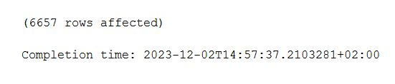
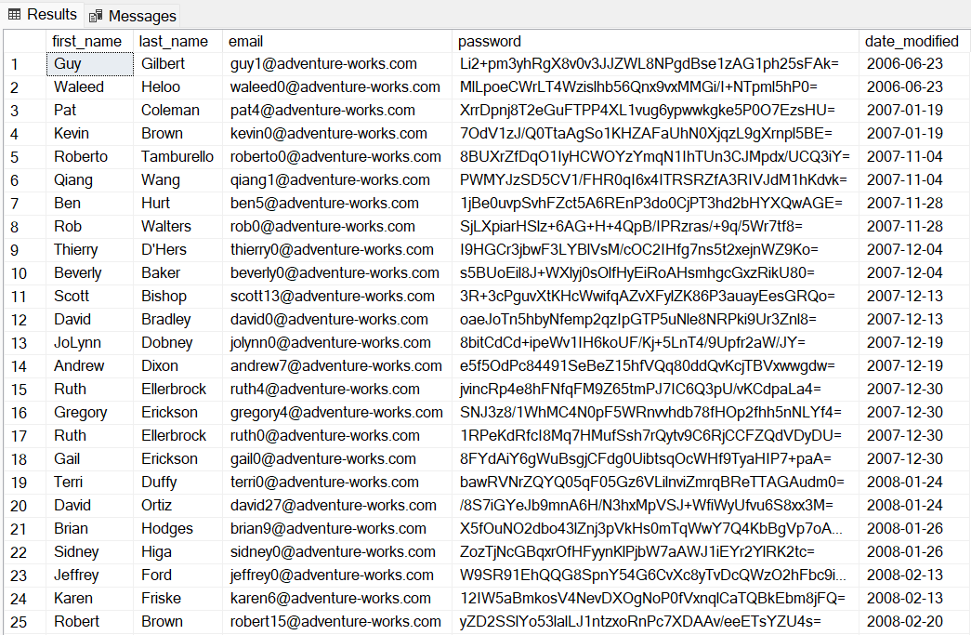

CREATE PROCEDURE AnalyzeProductPriceChanges
AS
BEGIN

CREATE TABLE dbo.product_analysis (
ProductID INT,
Name NVARCHAR(255),
Category NVARCHAR(50),
AveragePrice DECIMAL(18, 2),
LastPrice DECIMAL(18, 2),
LastPriceDate DATE,
PriceChangeCount INT
);

INSERT INTO product_analysis (ProductID, Name, Category, AveragePrice, LastPrice, LastPriceDate, PriceChangeCount)
SELECT p.ProductID,
p.Name AS ProductName,
pc.Name AS Category,
AVG(pch.StandardCost) AS AveragePrice,
MAX(pch.StandardCost) AS LastPrice,
MAX(pch.ModifiedDate) AS DateOfLastPrice,
COUNT(*) AS PriceCount
FROM Production.Product p
INNER JOIN Production.ProductSubcategory psc ON p.ProductSubcategoryID = psc.ProductSubcategoryID
INNER JOIN Production.ProductCategory pc ON psc.ProductCategoryID = pc.ProductCategoryID
INNER JOIN Production.ProductCostHistory pch ON p.ProductID = pch.ProductID
LEFT JOIN (
SELECT ProductID
FROM Purchasing.ProductVendor pv
INNER JOIN Purchasing.Vendor v ON pv.BusinessEntityID = v.BusinessEntityID
GROUP BY ProductID
) s ON p.ProductID = s.ProductID
GROUP BY p.ProductID, p.Name, pc.Name;
END;

USE [AdventureWorks2022]
GO

DECLARE @RC int
EXECUTE @RC = [dbo].[AnalyzeProductPriceChanges]
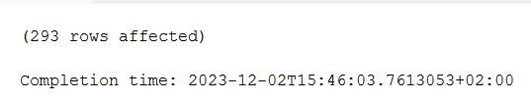
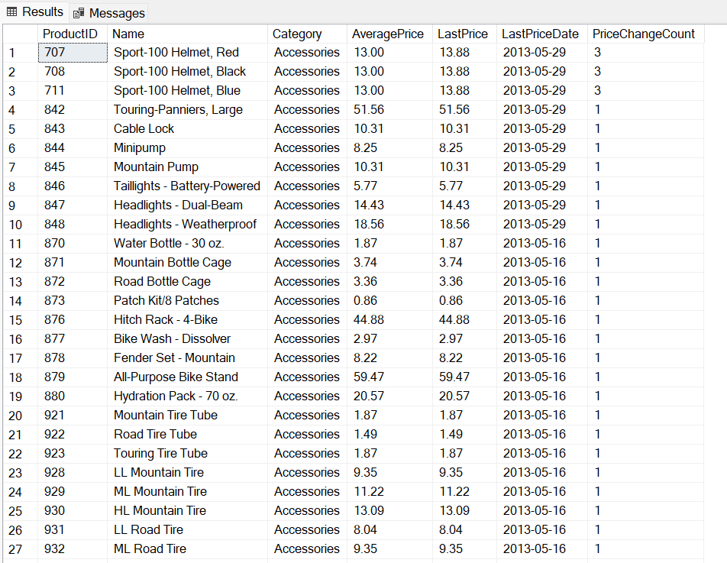
GO

